Project Name : Gesture controlled robot using Raspberry Pi

Objective : To Implement Gesture controlled robot using Raspberry Pi

Project report :

Step 1:

Load raspbian os on a micro sd card and insert into raspberry pi3 model B+.

Step 2:

Open Laptop’s Network sharing centre and share nework connection.

Step 3:

Make sure SSH server is enabled otherwise enable it manually.

Step 4:

Power on raspberry pi and connect a LAN cable with Laptop and pi.

Step 5:

Open Advance Ip scanner and copy the detected Ip address for raspberry pi.

Step 6:

Open MobaXterm and pest detected Ip address.

Step 7:

Default user name is = pi

Default password is = raspberry

Step8:

Update and upgrade your raspberry pi

>>sudo apt-get update

>>sudo apt-get upgrade

step9:

Install VNC server on raspberry pi, laptop and Phone for remote server control.

>>sudo apt-get install tightvncserver

and activate it.

>> tightvncserver

Step10:

>> sudo raspi-config

Open Networking option and enable wifi and connect it via phone.

Step11:

>>ifconfig

Copy your wlan0 ip address

>>netstat –nr

Copy your static router ip address

>>sudo nano /etc/dhcpcd.conf

On the nano editor

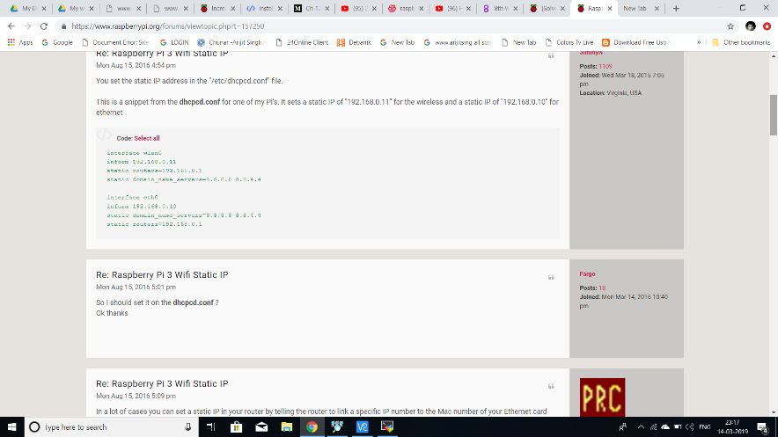

Step12:

Disconnect your LAN connection and see Raspberry pi is now connected via your phone. Laptop has connected via same network and now open MobaXterm and type static ip and it’s boom!!! Working working working .

Step13:

Install open cv

Click here: <https://www.alatortsev.com/2018/11/21/installing-opencv-4-0-on-raspberry-pi-3-b/>

Step14:

>> sudo raspi-config

Open interfacing divice and enable pi camera

Step15:

Make HARDWARE MODEL and connect it with Raspberry pi via GPIO poart

For me

GPIO11-pin23 -> en1 (H-bridge)

GPIO9-pin21 -> in1 (H-bridge)

GPIO10-pin19 -> in2 (H-bridge)

GPIO23-pin16 -> en2 (H-bridge)

GPIO24-pin18 -> in3 (H-bridge)

GPIO25-pin22 -> in4 (H-bridge)

Step16:

Programming:

Click here:

<https://drive.google.com/open?id=1Sh5yVkCqfjHLWJhdc5WSZIGe599BEuJc>

other raspberry pi3 model B+ Linux CMD:

echo>G:\ssh

ssh

pi

raspberry

sudo apt-get install tightvncserver

raspberrypi:1.log

sudo raspi-config

Camera=

PHOTO

raspistill

raspistill -o image.jpg

VIDEOS

raspivid

raspivid -o testvideo.h264 -t 10000

1.pwd

2.cd /home #change folder

3.~cd #Back to initial posi

4.ls #list the contents of a directory

5. mndir example

6.cd example/

7.nano test.py

8.python

9.quit() # Stop Python

10. wget http address

11.sudo apt-get install git

12.rm name #To remove some thing

13.rm -r folder name/

14.ls -a # All hidden content shown

15.ls -al

16.ls --all

17.ls --help

18.sudo apt-get update

19.sudo apt-get upgrade # install new package

20.sudo shutdown -h now #shut down

21. sudo shutdown -r now # restart

22.nano cameraexample.py

23.sudo apt-get install python-picamera

24.sudo apt-get install python-rpi.gpio

25.^ d #back to initial position

26. unzip abc.zip

27.nano name.py

28.python3 name.py

29.sudo nano /etc/dphys-swapfile

30.CONF_SWAPSIZE=100

31.source ~/.profile

32. sudo pip3 install imutils

Thank You